H.T No
Regulations:
A17

Sreenidhi Institute of Science and Technology
(An Autonomous Institution)
Code No: 6K504 Date: 29-Oct-2020 (AN)

B.Tech III-Year I-Semester External Examination, October - 2020 (Supplementary)
GEOTECHNICAL ENGINEERING (CIVIL)

Time: 2 Hours Max.Marks:75

Note: a) No additional answer sheets will be provided.
b) All sub-parts of a question must be answered at one place only, otherwise it will not be valued.
c) Missing data can be assumed suitably.

ANSWER ANY 5 OUT OF 8 QUESTIONS. EACH QUESTION CARRIES 15 MARKS.

1. |  | The In-situ density of an embankment, compacted at a water content of 12% was determined with the help of core cutter. The empty mass of core cutter was 1286g and the core cutter filled with a soil had mass of 3195g and the volume of core cutter is 1000cm3. Determine bulk density, dry density, porosity and degree of saturation.  Sketch the plasticity chart used for soil classification of fine grained soils in IS soil classification system and Give the group symbols for following soils  i) Liquid limit 40% and Plastic limit 22%  ii) Liquid limit 20% and Plastic limit 14%  iii) Passing through 4.75 mm sieve 70% and Passing through 75 micron sieve 15%, coefficient of curvature 3, coefficient of uniformity 7, PI= 3 | [15M]
2. | a) | For subsoil condition shown in below figure calculate total pore water pressure and effective stress at 1m, 3m and 6m below the ground level.  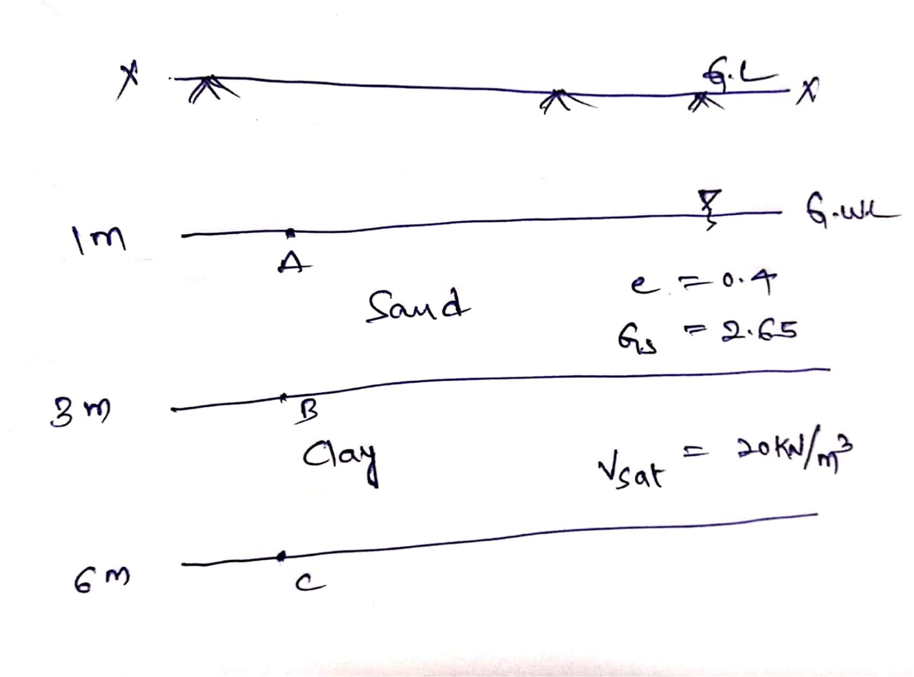 | [8M]
 | b) | A falling head permeability test is to be performed on a soil sample whose coefficient of permeability is 3x10⁵cm/s. What diameter of the stand pipe should be used if the head is to drop from 27.5cm to 20.0cm in 5 minutes and if the cross sectional area and length of the sample are respectively 15cm² and 8.5cm? | [7M]
3. | a) | Derive the Boussinsque theory for vertical stress due to concentrated load and explain about pressure bulb concept. | [8M]
 | b) | Determine the ultimate bearing capacity of strip footing 1.5m wide resting on a saturate clay having cohesion 30 kN/m² and friction angle 0 and unit weight is 20 kN/m³ at a depth of 2m below ground level. The water table is also at a depth of 2m from ground level. Calculate the percentage reduction in ultimate bearing capacity. | [7M]
4. | a) | Mention types of rollers used for field compaction? Explain two type rollers briefly? | [8M]
 | b) | In a consolidation test the pressure on a sample was increased from 150 to 300kN/m². The void ratio after 100% consolidation under 150kN/m² was 0.945, and that under 300kN/m² was 0.812. The coefficient of permeability of the soil was 25 x 10⁻⁶ mm/s and the initial height of the sample was 20mm. Determine The coefficient of compressibility, (ii) the coefficient of volume compressibility | [7M]
5. | a) | Write a note on the laboratory Triaxial shear test | [8M]
 | b) | A direct shear test was performed on a 6cm x 6cm sample of dry sand the normal load was 360N. The failure occurred at a shear load of 180N. Plot the Mohr strength envelope and determine ᴓ. Assume c=0 also determine principal stress at failure | [7M]
6. | a) | Explain the different methods of Soil Exploration and boring methods of Soil exploration? | [8M]
 | b) | Define Geophysical Investigation and Explain the Different methods of Geophysical investigation? | [7M]
7. | a) | What are the two basic structural units of clay minerals? Explain them | [8M]
 | b) | A soil profile consists of a surface layer of sand 3m thick (γ=16kN/m3), an intermediate clay layer 2m thick (γsat=19.25kN/m3), and a bottom layer of gravel 4m thick (γsat=19kN/m3). The water table is at the top of the clay layer. Determine the effective stress at various interfaces. | [7M]
8. | a) | A falling head permeability test is to be performed on a soil sample whose coefficient of permeability is 3x10⁵ cm/s What diameter of the stand pipe should be used if the head is to drop from 27.5cm to 20.0cm in 5 minutes and if the cross sectional area and length of the sample are respectively 15cm² and 8.5cm? | [8M]
 | b) | Explain and derive Variable head permeability test with neat sketches. | [7M]

-- 00 -- 00 –

